EAB – Navigate

Alerts and Cases Pilot

Review of Steps and Additional Resources

Additional Resources

Additional resources can be found within the Navigate tool by using the Help Center (? in top right corner). Once in the Help Center search for “cases” and/or “alerts.” *You must be logged into Navigate and the Help Center for the hyperlink to work.

Access to the alerts and cases functionality is permission based. Only those actively participating in the pilot will have access. If you believe you should have access and you do not, please email eabquestions@iastate.edu

Issuing Alerts

There are several ways a user can issue an alert. Below are the two most common.
From the staff home (2 steps)
1.
2.

Issuing an alert while viewing a student profile (2 steps)
1.
2.

Reviewing Alerts and Cases Assigned to You

There are several ways a user can manage cases in Navigate. Below is a walkthrough of the most common workflow.
From the staff home (6 steps)
1. Select the “cases” icon from the left-hand Navigation
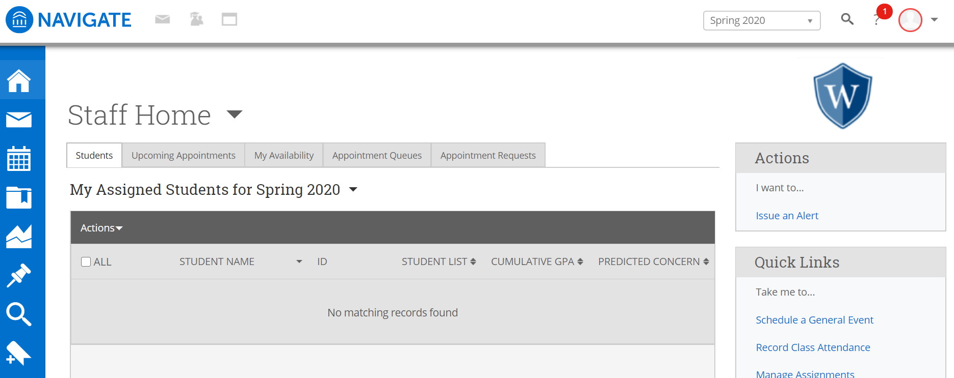
2. You will see any cases that are assigned to you. After reviewing the filters select “manage case” for the appropriate case.
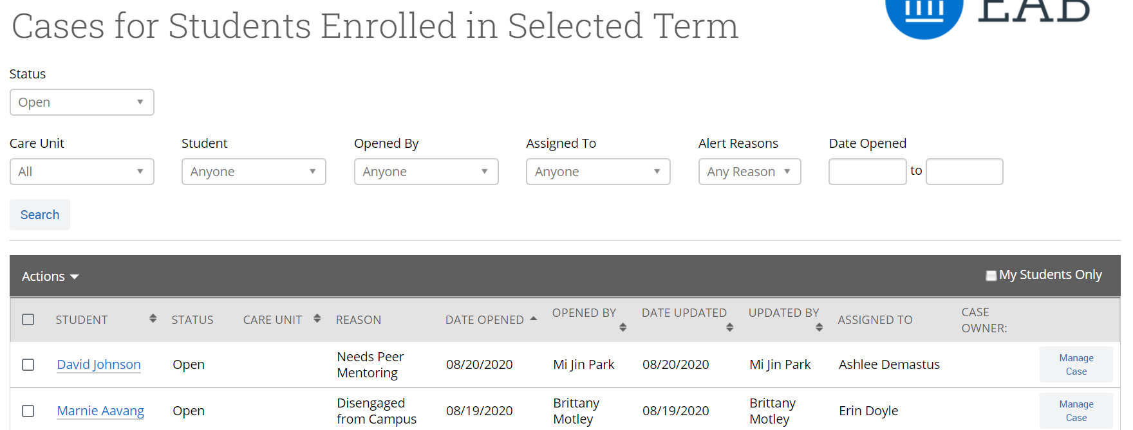
3. Add “comments” as appropriate
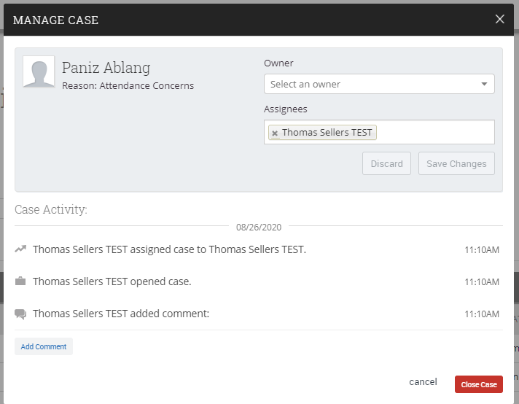
4. When case is addressed, select “close case”
5. Select appropriate “case close reason” and press “submit”
